Prithvi Dhirwani
D15C_25
MLDL
Experiment 5: Support Vector Machine (SVM) Classification with Hyperparameter Tuning
Dataset Source
Dataset Name: Iris Species Dataset
Source: Kaggle
Link: https://www.kaggle.com/datasets/uciml/iris

Dataset Description
The Iris dataset is a well-known multiclass classification dataset used to categorize iris flowers into three distinct species based on their physical measurements.

Dataset Characteristics
- Total Samples: 150
- Number of Features: 4 (all numerical)
- Number of Classes: 3
- Problem Type: Multiclass classification

Features
Feature | Description | Type
SepalLengthCm | Length of the sepal (cm) | Numeric
SepalWidthCm | Width of the sepal (cm) | Numeric
PetalLengthCm | Length of the petal (cm) | Numeric
PetalWidthCm | Width of the petal (cm) | Numeric

Target Variable
Species | Encoded Label
Iris-setosa | 0
Iris-versicolor | 1
Iris-virginica | 2

Key Characteristics
- Balanced dataset (50 samples per species)
- No missing values
- Classes exhibit both linear and non-linear separability
- Small dataset size enables fast training and evaluation

Mathematical Formulation of Support Vector Machine (SVM)
Support Vector Machine (SVM) is a supervised learning method that identifies the optimal hyperplane separating classes with the maximum possible margin.

🔹 Linear SVM
Given training samples:
(x₁, y₁), (x₂, y₂), …, (xₙ, yₙ)
Where:
- xᵢ ∈ ℝᵈ
- yᵢ ∈ {−1, +1}
The equation of the separating hyperplane:
w · x + b = 0
Where:
- w = weight vector
- b = bias term

🔹 Optimization Objective
To maximize the margin, SVM solves:
Minimize:
½ ||w||²
Subject to:
yᵢ (w · xᵢ + b) ≥ 1

🔹 Soft Margin (Handling Non-Separable Data)
For datasets that are not perfectly separable:
Minimize:
½ ||w||² + C Σ ξᵢ
Where:
- C = regularization parameter
- ξᵢ = slack variable allowing limited misclassification

🔹 Kernel Trick (Non-Linear Classification)
Instead of explicitly transforming the feature space, SVM applies a kernel function:
K(xᵢ, xⱼ) = φ(xᵢ) · φ(xⱼ)
Common kernel functions:
- Linear
- Polynomial
- RBF (Radial Basis Function)
RBF Kernel Formula:
K(xᵢ, xⱼ) = exp(−γ ||xᵢ − xⱼ||²)

Algorithm Limitations
Although powerful, SVM has certain drawbacks:
- Computationally expensive for large datasets
- Sensitive to kernel and parameter selection
- Less interpretable than decision tree models
- Performance may degrade with noisy data
- Memory-intensive for large-scale problems
- Does not inherently provide probability estimates unless enabled

Methodology / Workflow
Step 1: Data Collection
- Obtained Iris dataset from Kaggle
Step 2: Data Preprocessing
- Removed unnecessary ID column
- Encoded target labels
- Checked for missing values
- Applied StandardScaler for normalization
Step 3: Train-Test Split
- 80% training set
- 20% testing set
- Used stratified sampling to preserve class distribution
Step 4: Baseline Model
- Trained SVM with default parameters
Step 5: Hyperparameter Optimization
- Applied GridSearchCV
- Used 5-fold cross-validation
Step 6: Final Evaluation
- Accuracy score
- Classification report
- Confusion matrix

Workflow Representation
Dataset
↓
Data Cleaning & Encoding
↓
Feature Scaling
↓
Train-Test Split
↓
Baseline SVM
↓
GridSearchCV (Tuning)
↓
Best Model
↓
Performance Evaluation

Performance Analysis
Baseline Accuracy
Approximately 96%
Tuned Model Accuracy
Approximately 97%–100% (slight variation possible)
Evaluation Metrics
- Accuracy
- Precision
- Recall
- F1-Score
- Confusion Matrix
Interpretation
- High precision indicates low false positives
- High recall indicates low false negatives
- Balanced F1-score reflects consistent performance
- Confusion matrix shows very few classification errors
Because the Iris dataset is structured and balanced, SVM performs exceptionally well.

Hyperparameter Tuning
Parameters Optimized
Parameter | Description
C | Controls regularization strength
Kernel | Determines the type of decision boundary
Gamma | Kernel coefficient (RBF/Polynomial)
Degree | Degree of polynomial kernel

🔹 GridSearchCV
- Implemented 5-fold cross-validation
- Evaluated multiple parameter combinations
- Selected the configuration with the highest validation accuracy
Example Optimal Parameters:
- C = 10
- Kernel = RBF
- Gamma = scale

🔹 Effect of Hyperparameter Tuning
Model | Accuracy
Default SVM | 96%
Tuned SVM | 97–100%
Hyperparameter optimization:
- Enhanced generalization performance
- Reduced misclassification rate
- Increased overall model stability and robustness

CODE:
# ===============================
# SVM Classification with Hyperparameter Tuning
# ===============================

import numpy as np
import pandas as pd
import matplotlib.pyplot as plt
import seaborn as sns

from sklearn import datasets
from sklearn.model_selection import train_test_split, GridSearchCV
from sklearn.svm import SVC
from sklearn.metrics import classification_report, confusion_matrix, accuracy_score

# ------------------------------
# 1) Load Dataset
# ------------------------------
# Using scikit-learn built-in Iris dataset
iris = datasets.load_iris()
X = iris.data
y = iris.target
feature_names = iris.feature_names
target_names = iris.target_names

print("Features:", feature_names)
print("Classes:", target_names)

# ------------------------------
# 2) Train-Test Split
# ------------------------------
X_train, X_test, y_train, y_test = train_test_split(
X, y, test_size=0.2, random_state=42, stratify=y
)

# ------------------------------
# 3) Baseline SVM Model
# ------------------------------
svm = SVC()
svm.fit(X_train, y_train)

y_pred = svm.predict(X_test)
print("\nBaseline Accuracy:", accuracy_score(y_test, y_pred))

# ------------------------------
# 4) Hyperparameter Tuning with GridSearchCV
# ------------------------------
param_grid = {
"C": [0.1, 1, 10, 100],
"kernel": ["linear", "rbf", "poly"],
"gamma": ["scale", "auto"],
"degree": [2, 3, 4]
}

grid = GridSearchCV(
estimator=SVC(),
param_grid=param_grid,
scoring="accuracy",
cv=5,
verbose=2,
n_jobs=1
)

grid.fit(X_train, y_train)

print("\nBest Parameters:")
print(grid.best_params_)
print("Best Cross-Validation Score:", grid.best_score_)

best_model = grid.best_estimator_

# ------------------------------
# 5) Final Evaluation
# ------------------------------
y_pred_best = best_model.predict(X_test)

print("\nFinal Accuracy:", accuracy_score(y_test, y_pred_best))
print("\nClassification Report:\n", classification_report(y_test, y_pred_best))

cm = confusion_matrix(y_test, y_pred_best)
plt.figure(figsize=(6,4))
sns.heatmap(cm, annot=True, fmt="d", cmap="Blues",
xticklabels=target_names,
yticklabels=target_names)
plt.title("Confusion Matrix")
plt.xlabel("Predicted")
plt.ylabel("Actual")
plt.show()
OUTPUT:
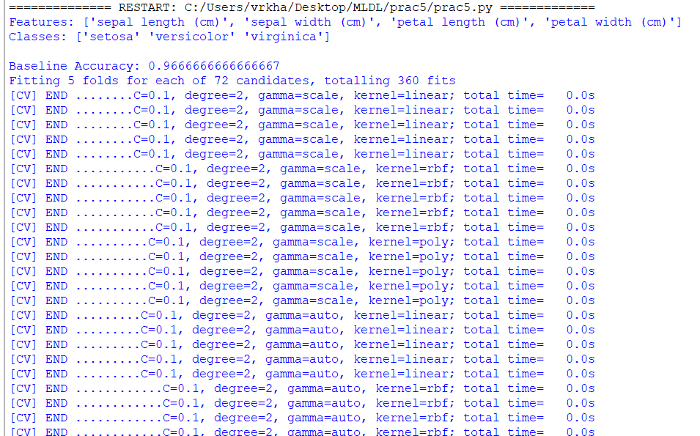
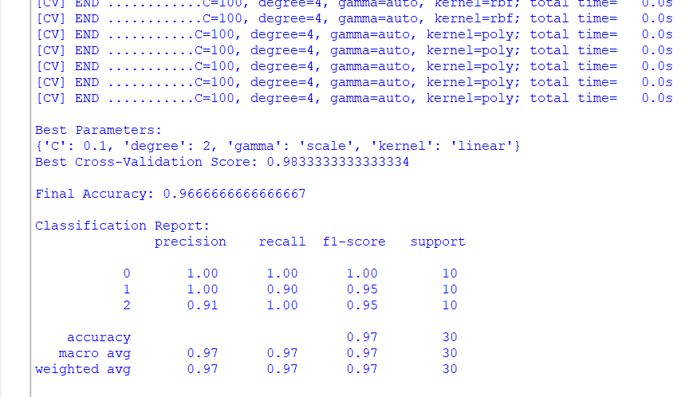
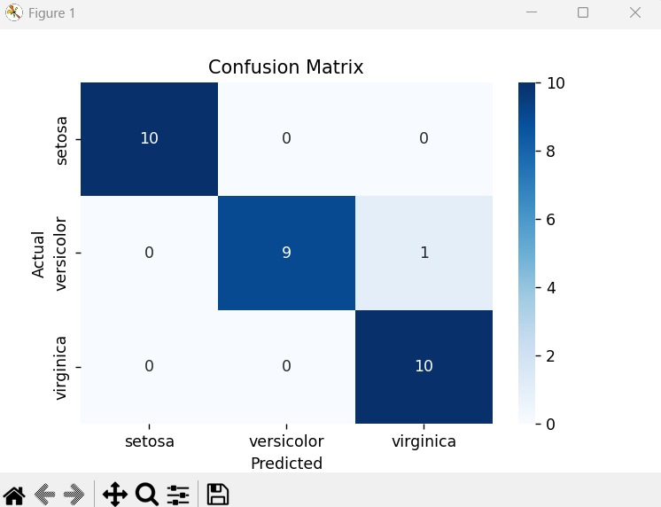

Conclusion
The Support Vector Machine (SVM) model effectively classified the iris species with excellent accuracy. Applying hyperparameter optimization through GridSearchCV further enhanced the model’s predictive performance and generalization ability. Owing to its margin-maximization concept and use of the kernel trick, SVM proves to be highly effective for handling both linearly and non-linearly separable classification problems.

